myPostCare Launch for People Seeking an Abortion
myPostCare is a comprehensive digital platform that supports individuals after a surgical abortion. It was co-created in British Columbia, Canada, with women’s health specialists and individuals who experienced a surgical abortion. The site was developed with a user-centered design approach to ensure feasibility and acceptability of the web platform among the target audience. With the first research phases complete, myPostCare is launching to the public the week of June 14, 2021. This communications toolkit contains content to be used in myPostCare’s launch.
All graphics in this package can be downloaded here: https://drive.google.com/drive/folders/1eC0zDdAJJT9dr9g2i6nBLw_CrQMzuf2L?usp=sharing

Principle Investigator – Dr. Roopan Gill – rgill@vitalaglobal.org
Project Director – Dr. Genevieve Tam – gtam@vitalaglobal.org
Research Assistant – Dr. Hillary Pearson – hillary@vitalaglobal.org
Prep of Comms Toolkit – Candice Taguibao – Candice.taguibao@cw.bc.ca

Promotion Plan
Audience: This communications toolkit is tailored for women and non-binary individuals seeking an abortion or. A separate toolkit was created for care providers.
Geographic scope: Canada, nationwide
Hashtags
Recommended | Optional
#myPostCare | #selfcare
#VitalaGlobal | #sexualhealth
#abortion | #abortioncare
#reproductivehealth | #covid19
#womenshealth | #contraception
#digitalhealth | #reprojustice

FACEBOOK
Are you looking for information and resources on surgical abortion? myPostCare is a web-based tool which was designed to provide women and non-binary people with support following surgical abortion. The site includes information on post-procedure care, emotional well-being, contraception, sexual health, and other resources in the community such as talk lines, counselling, and more.
You are not alone. Empower yourself with knowledge and learn about the resources in your community. Check out myPostCare today.
Learn more at: mypostcare.ca

GRAPHIC:
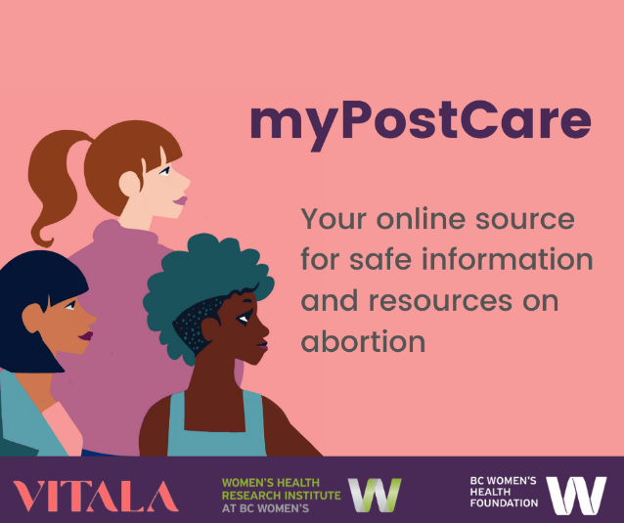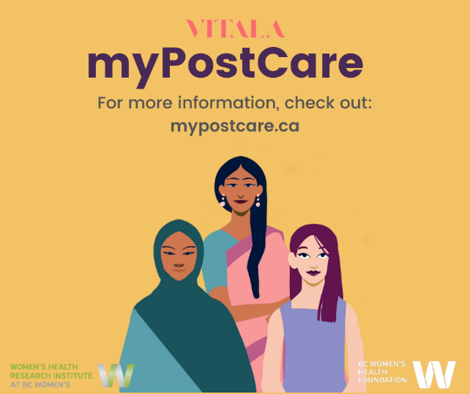

INSTAGRAM
myPostCare is a web-based tool which was designed to provide women and non-binary people with support, information, and resources for surgical abortion. The site includes evidence-based information on post-procedure care, emotional well-being, contraception, sexual health, and other resources in the community such as talk lines, counselling, and more.
You are not alone. Empower yourself with knowledge and learn about the resources in your community. Check out myPostCare today.
@vitalaglobal
myPostCare is a comprehensive web-based tool which provides information and resources to women and non-binary individuals after surgical abortion. Developed with a user-centered approach, myPostCare provides information on post-procedure care, emotional well-being, contraception, sexual health, and other resources in the community such as talk lines, counselling, and more.
myPostCare is now available to the public! Tell your patients about myPostCare today and connect them with safe information and resources in their community.
[myPostCare link]
@vitalaglobal

ACCOUNTS - Option to tag the following accounts in the picture to reach a larger audience.
Institution | Handle
Vitala Global | @vitalaglobal
The Women's Health Research Institute | @womensresearch
The University of British Columbia | @UBC
Women on Web | @WoWabortionpill
Action Canada | @actioncanadashr
Women’s College Hospital | @WCHospital
National Abortion Federation | @NatAbortionFed
Jennifer Gunter | @DrJenGunter

TWO PANEL GRAPHIC:
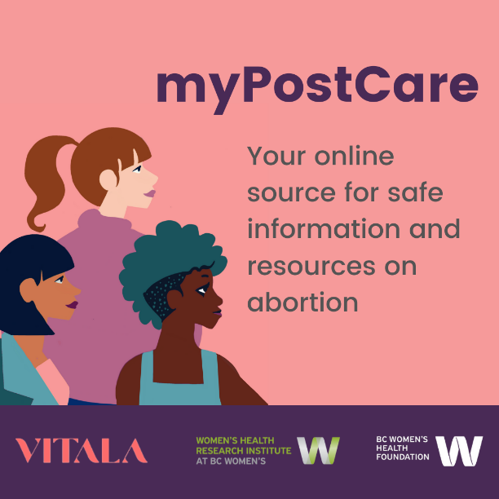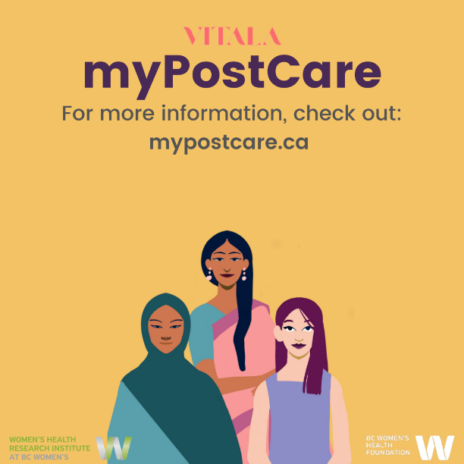

TWITTER
Support is available for those seeking a surgical abortion. myPostCare is a webtool developed with patient voices driving design.
You are not alone. Empower yourself with knowledge and learn about the resources in your community.
Read more: mypostcare.ca

ACCOUNTS - Option to tag the following accounts in the picture to reach a larger audience.

Institution | Handle
Vitala Global | @vitalaglobal
The Women's Health Research Institute | @womensresearch
The University of British Columbia | @UBC
Women on Web | @WoWabortionpill
Action Canada | @actioncanadashr
Women’s College Hospital | @WCHospital
National Abortion Federation | @NatAbortionFed
Jennifer Gunter | @DrJenGunter

GRAPHIC:
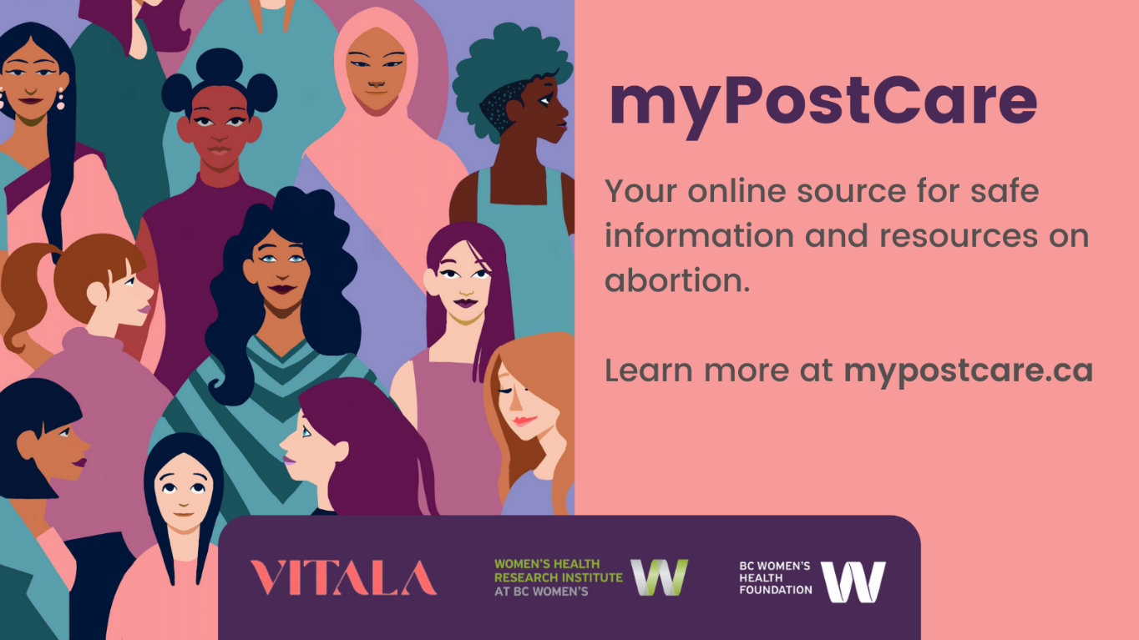

Website Blogpost
This week, myPostCare, a comprehensive web-based tool which provides support to women and non-binary individuals after surgical abortion, is launching to the public. myPostCare was developed by researchers from Vitala Global with a user-centred approach, creating a tool where the voices of those who have experienced surgical abortions drove design.
Today in Canada, more than 30% of women have had an abortion and yet, many who have undergone a procedure have reported their experience as isolating. Barriers such as stigma and geography can limit access to abortion services and information. In an early research phase for myPostCare, women who had undergone an abortion indicated a lack of resources and emotional support, particularly in rural settings, highlighting a gap for accessible, confidential, and comprehensive abortion information and care.
“Emotionally it was harder than I expected it to be … even though I knew it was the right thing to do. It still brought up a lot of emotional questions and feelings.”
“I live in a remote community… So, I probably wouldn’t even feel comfortable going to somebody [for information or services related to abortion] because it’s a small town.”
myPostCare offers information on post-procedure care, emotional well-being, contraception, sexual health, and other resources in the community such as talk lines, counselling, and more. Feasibility and acceptability research revealed that myPostCare is easy to use and useful for people who are seeking an abortion.
If you are seeking an abortion, you are not alone. Empower yourself with information and connect yourself to a community -- learn about myPostCare today.
Learn more at mypostcare.ca

GRAPHICS (if allowed):

