myPostCare Launch for Care Providers
myPostCare is a comprehensive digital platform that supports individuals after a surgical abortion. It was co-created in British Columbia, Canada, with women’s health specialists and individuals who experienced a surgical abortion. The site was developed with a user-centered design approach to ensure feasibility and acceptability of the web platform among the target audience. With the first research phases complete, myPostCare is launching to the public the week of June 14, 2021. This communications toolkit contains content to be used in myPostCare’s launch.
All graphics in this package can be downloaded here: https://drive.google.com/drive/folders/1HxneXDtVQ-HSTDa0iyqkqCLWUBLfj4lV?usp=sharing

Principle Investigator – Dr. Roopan Gill – rgill@vitalaglobal.org
Project Director – Dr. Genevieve Tam – gtam@vitalaglobal.org
Research Assistant – Dr. Hillary Pearson – hillary@vitalaglobal.org
Prep of Comms Toolkit – Candice Taguibao – Candice.taguibao@cw.bc.ca

Promotion Plan
Audience: This communications toolkit is tailored for care providers who can refer their patients to myPostCare. A separate toolkit was created for an audience of women/those who may be seeking a surgical abortion.
Geographic scope: Canada, nationwide
Hashtags
Recommended | Optional
#myPostCare | #selfcare
#VitalaGlobal | #sexualhealth
#abortion | #abortioncare
#reproductivehealth | #covid19
#womenshealth | #contraception
#digitalhealth | #reprojustice
Website

I.e., WHRI News & Events Blogpost
This week, myPostCare, a comprehensive web-based tool which provides support to women and non-binary individuals after surgical abortion, is launching to the public. myPostCare was developed by researchers from Vitala Global with a user-centred approach, creating a tool where the voices of those who have experienced surgical abortions drove design.
Today in Canada, more than 30% of women have had an abortion and yet, many who have undergone a procedure have reported their experience as isolating. Barriers such as stigma and geography can limit access to abortion services and information. In an early research phase for myPostCare, women who had undergone an abortion indicated a lack of resources and emotional support, particularly in rural settings, highlighting a gap for accessible, confidential, and comprehensive abortion information and care.
“Emotionally it was harder than I expected it to be … even though I knew it was the right thing to do. It still brought up a lot of emotional questions and feelings.”
“I live in a remote community… So, I probably wouldn’t even feel comfortable going to somebody [for information or services related to abortion] because it’s a small town.”
myPostCare offers evidence-based information on post-procedure care, emotional well-being, contraception, sexual health, and other resources in the community such as talk lines, counselling, and more. Feasibility and acceptability research revealed that myPostCare is easy to use and useful for people seeking an abortion.
If you are a health care provider, myPostCare can complement in-person follow-up after a procedure, to provide your patients who are seeking an abortion with accessible and comprehensive information and support resources. Women and non-binary folk seeking abortions are not alone. Tell them about myPostCare today.
https://mypostcare.ca/

GRAPHIC: (if allowed)

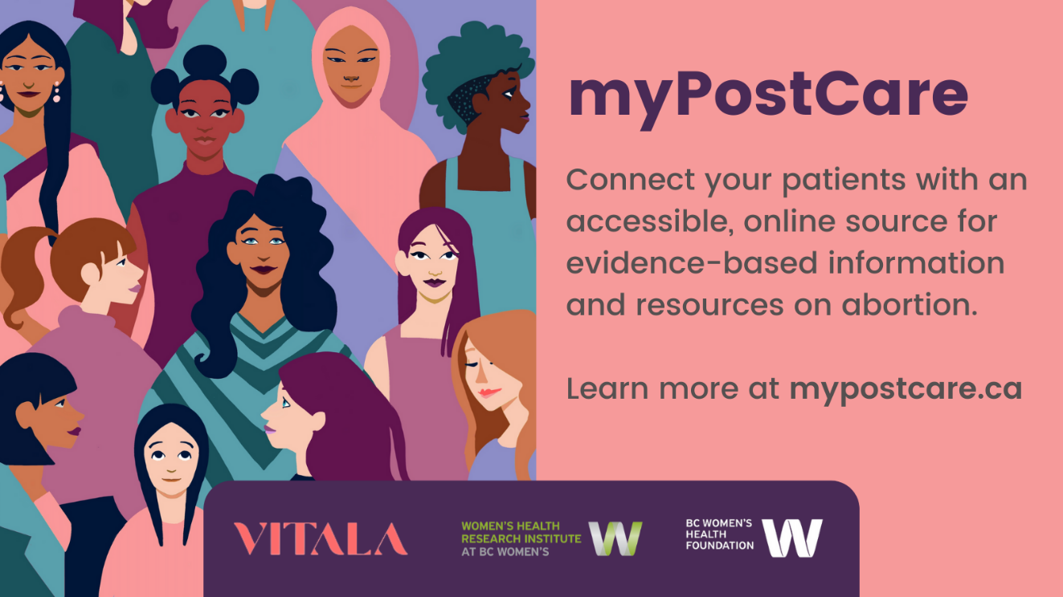
FACEBOOK
Health care providers – myPostCare has just launched! myPostCare is a comprehensive web-based tool which provides evidence-based information and resources to women and non-binary individuals after surgical abortion. Developed with a user-centered design approach, myPostCare provides information on post-procedure care, emotional well-being, contraception, sexual health, and other resources in the community such as talk lines, counselling, and more.
Women and non-binary folk who undergo surgical abortion often feel alone and unsupported. They don’t have to. Tell your patients about myPostCare today and connect them with safe information and resources in their community.
Learn more at: mypostcare.ca

GRAPHIC:
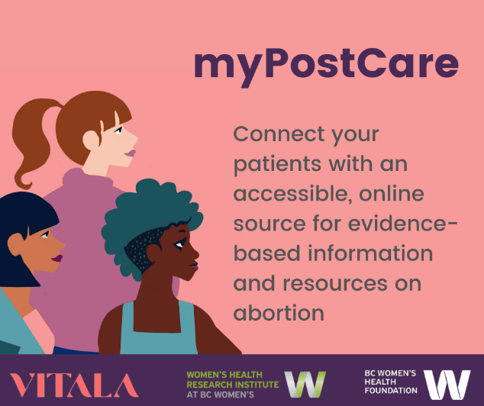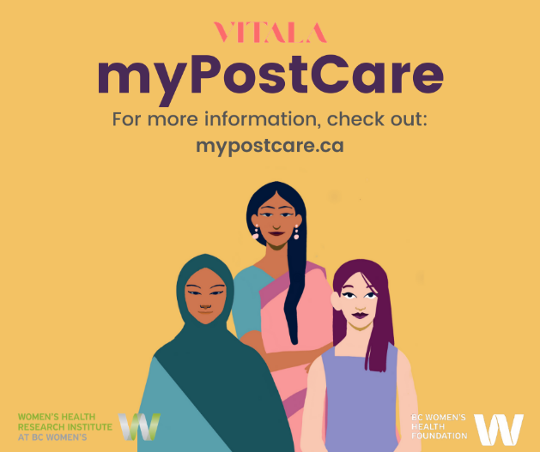

Editable images can be found here

INSTAGRAM
myPostCare is a comprehensive web-based tool which provide support to women and non-binary individuals after surgical abortion. Developed with a user-centered design approach, myPostCare provides evidence-based information on post-procedure care, emotional well-being, contraception, sexual health, and other resources in the community such as talk lines, counselling, and more.
myPostCare is now available to the public! Tell your patients about myPostCare today and connect them with safe information and resources in their community.
Learn more at mypostcare.ca
@vitalaglobal

ACCOUNTS - Option to tag the following accounts in the picture to reach a larger audience.

TWO PANEL GRAPHIC:
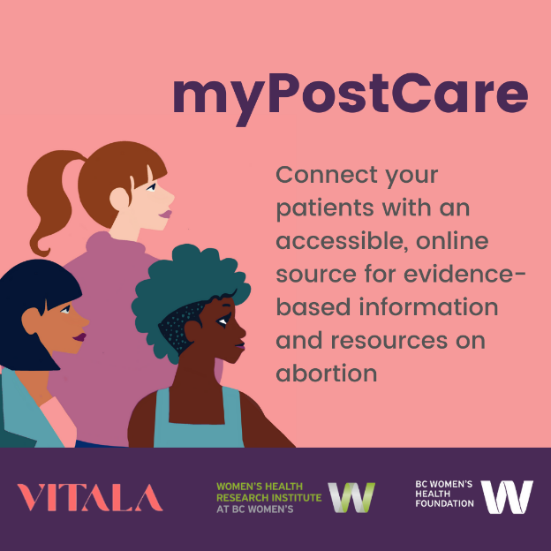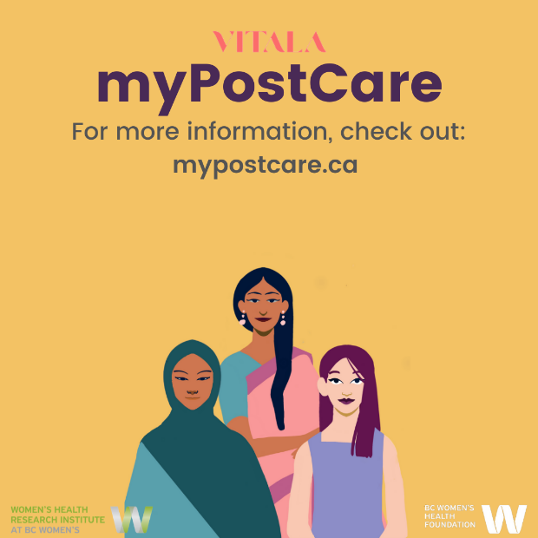

Editable images can be found here

TWITTER
Do you want to connect your patients with comprehensive post-abortion information and resources? Tell them about myPostCare! myPostCare is a webtool developed by researchers @VitalaGlobal using a user-centered design approach, to support people following surgical abortion.
Read more: mypostcare.ca

ACCOUNTS - Option to tag the following accounts in the picture to reach a larger audience.
Institution | Handle
Vitala Global | @VitalaGlobal
The Women's Health Research Institute | @WomensResearch
The University of British Columbia | @UBC
BC Women’s Foundation | @BCWomensFdn
Action Canada | @actioncanadashr
National Abortion Federation | @NatAbortionFed
University of Toronto | @uoftobgyn
Women’s College Hospital | @WCHospital

GRAPHIC:

Editable images can be found here

Print Poster – Option 1
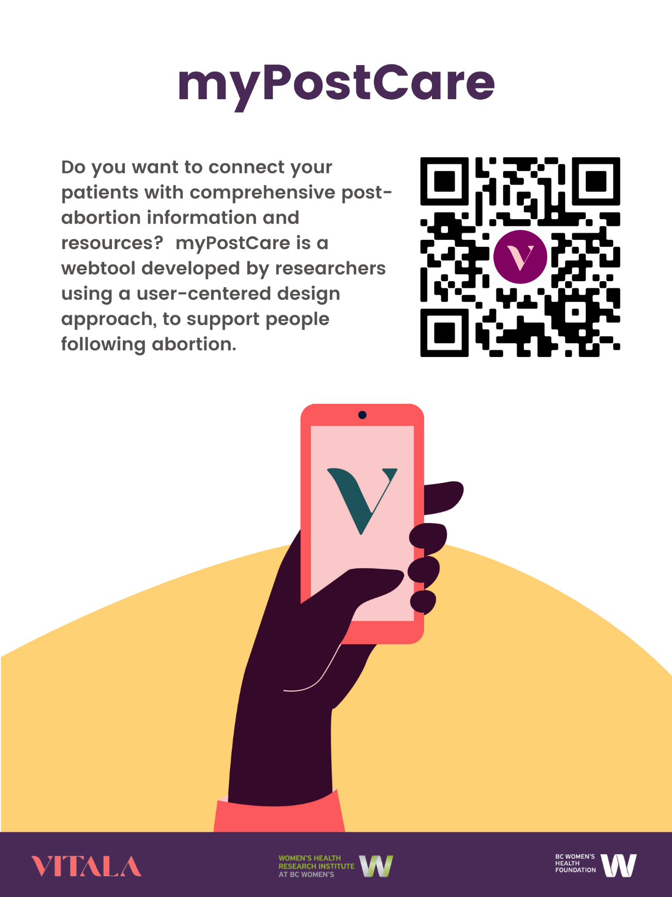
Editable images can be found here

Print Poster – Option 2
