Women’s Health Research Institute

@WomensResearch
Wellness Exchange

FREE VIRTUAL EVENT
December 10, 2020
5pm – 6:30pm PST

CONTACT: Nicole Prestley
Nicole.Prestley@cw.bc.ca

Sample Website/Newsletter Copy
Join the Women’s Health Research Institute for their first virtual @WomensResearch Wellness Exchange!
This FREE public event will be emceed by Shirley Weir of MenopauseChicks.com, and feature talks on endometriosis, COVID-19 + pregnancy, health literacy, a prenatal and parenting text-messaging education program, and the hosts of the new GOSH podcast on gynecologic cancer survivorship.
Don’t miss out – register today!
https://www.eventbrite.ca/e/womensresearch-wellness-exchange-tickets-129886178055

PHOTO TO GO ALONG WITH POSTS:

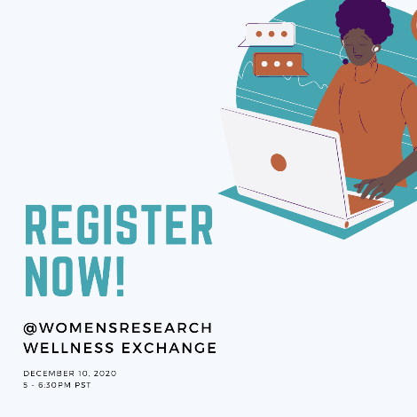

Click here to download

FACEBOOK
Join the Women’s Health Research Institute for their first virtual @WomensResearch Wellness Exchange!
The event will be emceed by Shirley Weir of MenopauseChicks.com, and feature speakers on endometriosis, COVID-19 + pregnancy, health literacy, a prenatal and parenting text-messaging education program, and the hosts of the new GOSH podcast on gynecologic cancer survivorship.
Don’t miss out – register today!
Event link: https://fb.me/e/1PHFprdDL

PHOTO TO GO ALONG WITH POSTS:

Click here to download

INSTAGRAM
Join @WomensResearch for their first virtual Wellness Exchange!
The event will be emceed by @menopausechicks and feature speakers on #endometriosis, #COVID19 + #pregnancy, health literacy, a #prenatal and #parenting text-messaging education program, and the hosts of the new GOSH podcast on #GynecologicCancer survivorship.
Don’t miss out – visit @WomensResearch’s page for details and registration!

PHOTO TO GO ALONG WITH POSTS:

Click here to download

TWITTER
Tune in for @womensresearch’s live virtual event on December 10th! Featuring speakers on #endometriosis, #COVID19 + #pregnancy, health literacy, a #prenatal and #parenting text-messaging education program, and the hosts of the new GOSH podcast on #GynecologicCancer survivorship. Register now >> https://www.eventbrite.ca/e/womensresearch-wellness-exchange-tickets-129886178055
Have you registered for the @WomensResearch Wellness Exchange? This free virtual event will be emceed by @MenopauseChicks and will feature a variety of women’s health experts. Don’t miss out – register today! https://www.eventbrite.ca/e/womensresearch-wellness-exchange-tickets-129886178055
Do you have questions about #COVID19 and #pregnancy? Tune into the @WomensResearch Wellness Exchange on December 10th for the latest findings from @money2_dmoney, lead on @CANCOVID-Preg. Register now >> https://www.eventbrite.ca/e/womensresearch-wellness-exchange-tickets-129886178055
Did you know British Columbians can receive free prenatal education by text message? Learn more at the @WomensResearch Wellness Exchange. Details and registration >> https://www.eventbrite.ca/e/womensresearch-wellness-exchange-tickets-129886178055
Have you heard of the GOSH podcast? The @GCI_Cluster is amplifying survivors’ voices through this new project. Learn more at the @WomensResearch Wellness Exchange! Register now >> https://www.eventbrite.ca/e/womensresearch-wellness-exchange-tickets-129886178055
Did you know #endometriosis can cause painful sex? Join @WomensResearch on December 10th for their first virtual Wellness Exchange to learn more! https://www.eventbrite.ca/e/womensresearch-wellness-exchange-tickets-129886178055 @PelvicPainEndo
How do you know if the health information you read online is credible? Learn some tips for assessing it from @BCWomensHosp health literacy specialist Pamela Harrison and #digitalhealth manager Dr. Beth Payne at the @WomensResearch Wellness Exchange! Details >> https://www.eventbrite.ca/e/womensresearch-wellness-exchange-tickets-129886178055

PHOTO TO GO ALONG WITH POSTS:

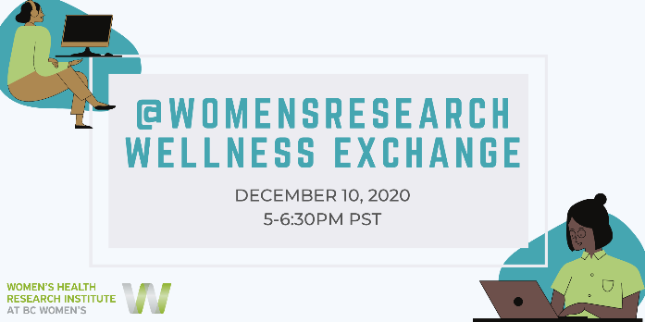

Click to download

