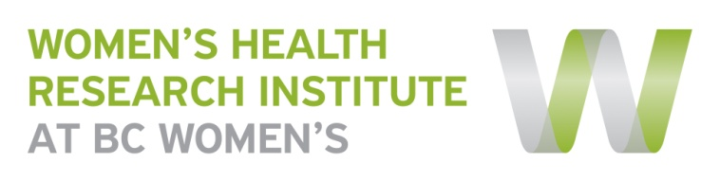
WHRI Website:
Research Project Template

Please complete one form per research project/program you would like displayed on the WHRI website. This page will provide you with a space to help recruit participants, disseminate findings and showcase other knowledge translation activities resulting from the study. The content you provide in this form will be connected to the research team’s bios provided by the membership information. If any of these fields do not apply to this project, please leave them blank.

If there are supporting documents you would like embedded on the project page (i.e. consent forms) or if you have any questions regarding this form, please contact Nicole Prestley at Nicole.Prestley@cw.bc.ca or by phone 604-875-2424 ext 4956.
Title:  (same as consent form) | “The Impact of Prenatal Screening for Fetal Aneuploidy on Maternal-Infant Bonding” (Pre-MIB) Study
Principal Investigator: | Catriona Hippman, MSc, CGC, 604-875-2000 ext 4733
Primary Contact:  (name, title, phone, email) | Nicole Prestley, Research Program Manager, 604-875-2424 ext 4956, Nicole.Prestley@cw.bc.ca
About the Study:  (100 words or less plain language summary) | The purpose of this study is to assess how the option to have prenatal genetic screening for chromosome abnormalities can impact maternal-infant bonding during pregnancy. Chromosome abnormalities take place when an abnormal number of chromosomes are within a cell, which is known to be the cause of certain birth defects. Maternal-infant bonding (MIB) is the term used to describe the affectionate relationship that develops between a mother and her fetus/infant. The study involves participants completing a questionnaire and interview, with a total time commitment of 1 hour and 30 minutes.
Why is this research important? | A strong MIB has been known to promote healthy lifestyle choices during pregnancy and positive longer-term consequences for later maternal-child interactions. MIB can be threatened by prenatal stress, and prenatal stress can be experienced during the prenatal genetic screening process. It is hoped that the results from this study can improve maternal-infant bonding and women’s experiences of prenatal genetic screening.
Study Status:  (e.g. recruiting, data analysis, manuscript development, complete) | Recruiting & data analysis
Who can participate:  (short description, attach consent form) | Eligible subjects will:  - Be over the age of 19;  - Be fluent in English;  - Be between 26 to 34 weeks gestation;  - Have chosen whether or not to have prenatal genetic screening.
Study Results/Publication: | Preliminary results have been presented as an abstract at the 2015 conferences of the National Society of Genetic Counselors and Canadian Association of Genetic Counsellors. The abstract has been published in the Journal of Genetic Counseling:  Hippman, C., Austin, J.C. Does a negative prenatal genetic screen result impact maternal-fetal bonding? Journal of Genetic Counseling. 2015. 24(6). p1086.
Co-Investigators: | Jehannine Austin, PhD, (C) CGC
Funded by: | National Society of Genetic Counselors, Prenatal Special Interest Group Grant Award
Partners:
Other Attachments:
(e.g. Newsletters, videos)

