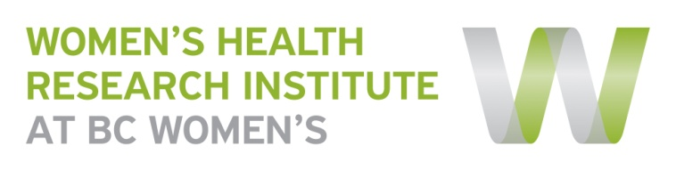
WHRI Website:
Research Project Template

Please complete one form per research project/program you would like displayed on the WHRI website. This page will provide you with a space to help recruit participants, disseminate findings and showcase other knowledge translation activities resulting from the study. The content you provide in this form will be connected to the research team’s bios provided by the membership information. If any of these fields do not apply to this project, please leave them blank.999

If there are supporting documents you would like embedded on the project page (i.e. consent forms) or if you have any questions regarding this form, please contact Nicole Prestley at Nicole.Prestley@cw.bc.ca or by phone 604-875-2424 ext 4956.
Title:  (same as consent form) | Protocol #AI438-047: A Multi-arm, Phase 3, Randomized, Placebo Controlled, Double Blind Clinical Trial to Investigate the Efficacy and Safety of BMS-663068 in Heavily Treatment Experienced Subjects Infected with Multi-drug Resistant HIV-1
Principal Investigator: | Dr Melanie Murray
Primary Contact:  (name, title, phone, email) | Dr Melanie Murray, Assistant Professor, UBC & Adult Physician, Oak Tree Clinic, 604 875 2212  Evelyn Maan, Oak Tree Clinic Research Manager, 604 767 5044
About the Study:  (100 words or less plain language summary) | The purpose of this study is to determine if using a new investigational antiretroviral drug given twice a day, along with other HIV medications, is safe and effective for the treatment of people living with HIV. The drug is part of a new class of HIV drugs being studied for the treatment of HIV and prevents the HIV virus from attaching to CD4 immune cells. Participants in this research study must be “Heavily Treatment Experienced”. This means you must have taken many HIV medications and must have developed resistance or become intolerant to many of them.
Why is this research important? | HIV is now considered a chronic disease that requires life-long therapy and people living with HIV are living longer and better lives. However, not all HIV medications work for all people and problems with side effects, with tolerating these medications and with being able to take them regularly can lead to resistance. When the HIV virus becomes resistant to HIV medications, the medications do not work well and people can feel sick again. New HIV medications that work differently than the kinds that are currently available could help people who have tried a lot of HIV medications and have a lot of resistance to find a combination of medications that work better to fight the HIV. It is important to give the investigational drug to large groups of people to confirm its effectiveness, monitor side effects, compare it to commonly used treatments, and collect information to determine whether the experimental drug or treatment can be used safely.
Study Status:  (e.g. recruiting, data analysis, manuscript development, complete) | Recruitments ends soon.
Who can participate:  (short description, attach consent form) | You may be able to participate in this study if you are an adult living with HIV-1 and have a viral load greater than 400 copies/ml. You must have also tried lots of HIV medicines and have resistance to at least 1 drug in 3 or more of all approved classes of HIV medicines.
Study Results/Publication:
Co-Investigators: | Dr Neora Pick  Dr Mary Kestler
Funded by: | Bristol-Myers Squibb (BMS)
Partners:
Other Attachments:
(e.g. Newsletters, videos)

